
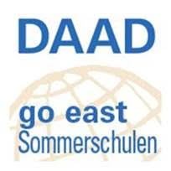
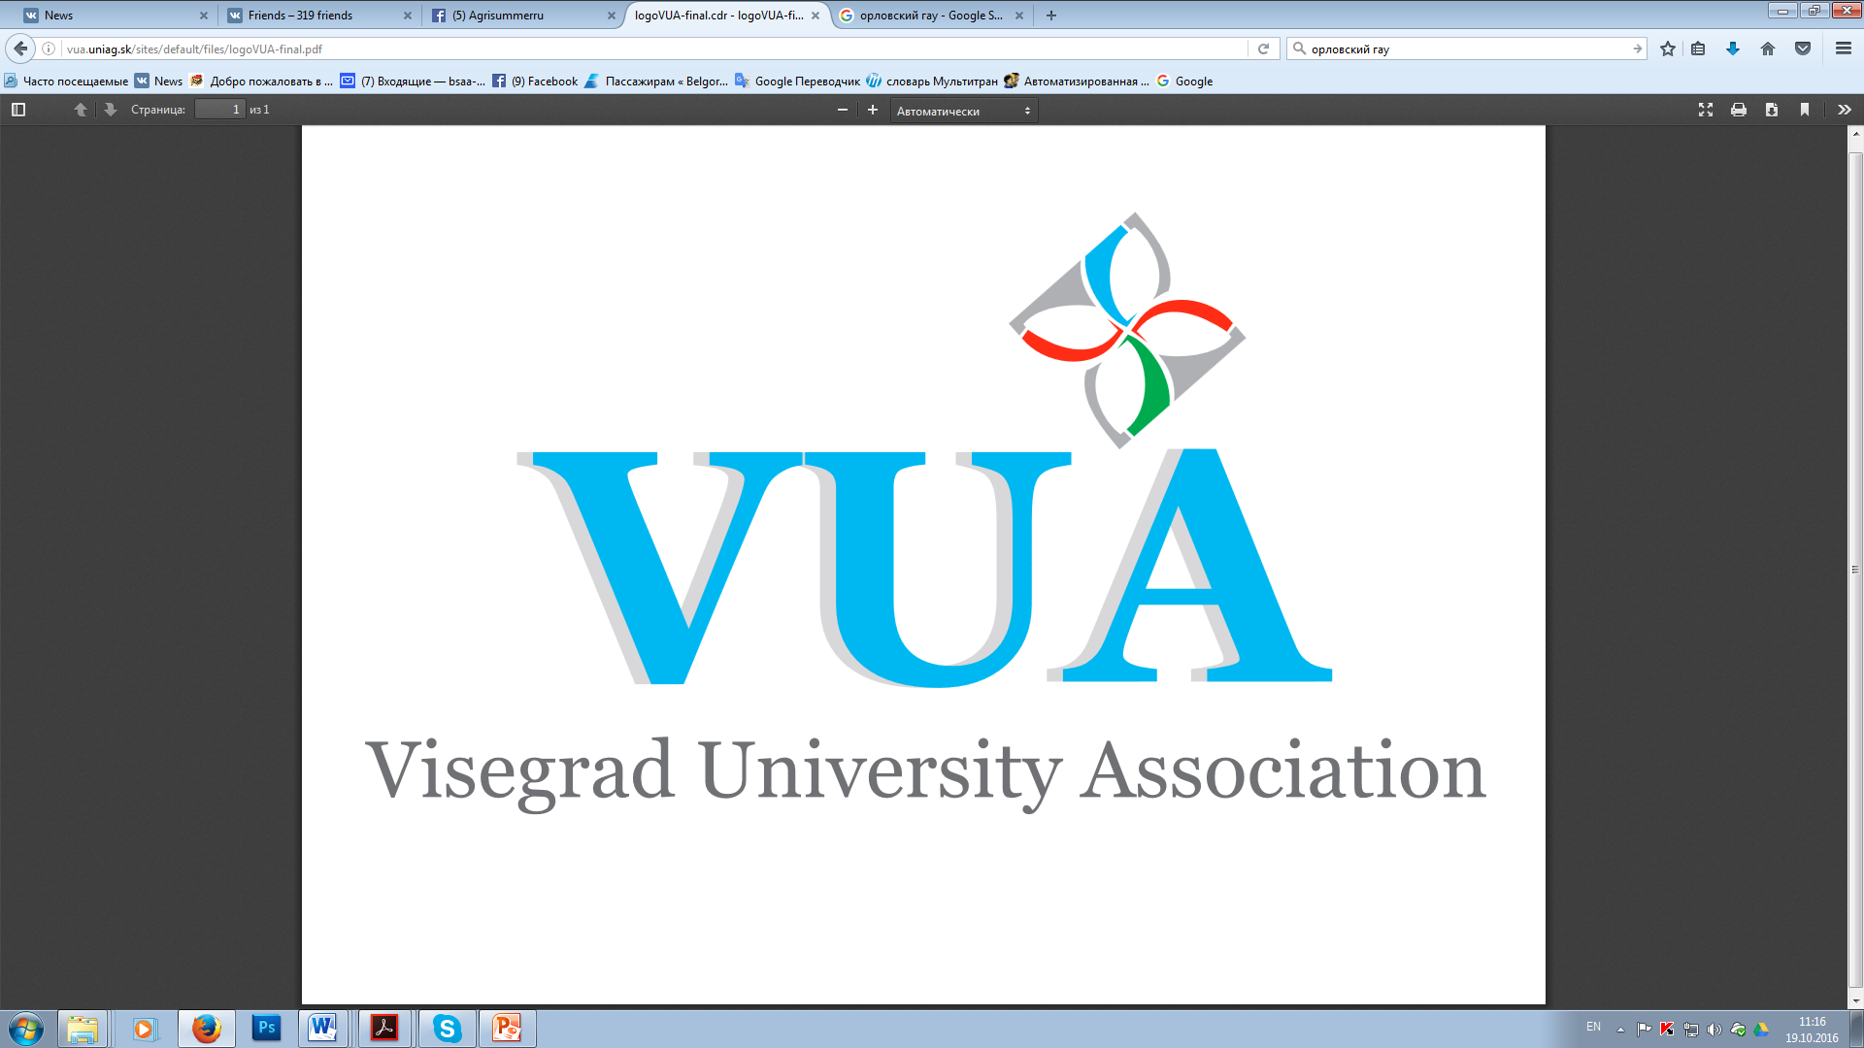
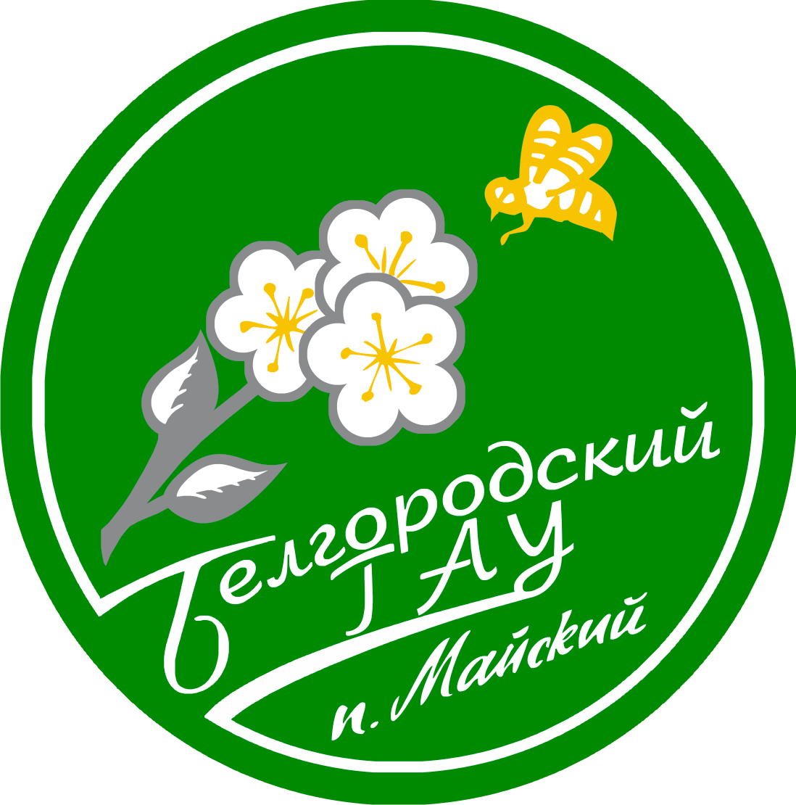

International Summer School
“Agricultural Production for Sustainable Development”

PRELIMINARY PROGRAMME
PART I

Michurisnk State Agrarian University
July 25-August 1, 2021
Time | Activity
25.07.2021
13.30 | Arrival, accommodation, lunch, free time
18.00-19.00 | Dinner
19.00 – 21.00 | Excursion to the city
26.07.2021
8.30 – 9.30 | Breakfast
9.45 – 10.30 | Presentation 1: Summer school opening and university presentation
10.30 – 12.00 | Presentation 2: Association of agrarian education in the central part of Russia as an expert training resource for food security provision
12.00-13.00 | Excursion to the university campus
13.00 – 14.00 | Lunch
14.00 – 15.30 | Presentation 3. Agricultural production in Tambov region. Michurinsk as a science city in horticulture
15.30 – 17.00 | Visit to the Federal Research Center of Horticulture
17.00 – 18.00 | Language practice (optional): “Easy Russian”
18.00 – 19.00 | Dinner
27.07.2021
8.30 – 9.30 | Breakfast
9.45 – 11.15 | Presentation 4: Import substitution and food security provisions in Tambov region and Central Black Earth Zone of Russia: horticulture and crop production
11.30 – 13.00 | Master-class: Soil science for high yields and soil ecology. (Trip field to the university experimental farm “Komsomolets”. Soil profile analysis). In cooperation with the fertilizers production company “August”.
13.00– 14.00 | Lunch
14.00– 18.00 | Excursions to the vegetable production company “Teplichnoye”.
18.00 – 19.00 | Dinner
19.00 – 20.00 | Cultural aspect (optional): Making ancient Russian talisman dolls with your own hands.
28.07.2021

8.30 – 9.30 | Breakfast
9.45-11.15 | Presentation 5: Horticulture as the key issue of Tambov Region development. Horticultural traditions of Michurin and Budagovskiy.
11.30-13.00 | Presentation 6: The ways to intensify horticulture in Russia. High density orchards and the environment.
13.00 – 14.00 | Lunch
14.00 – 16.00 | Visit to the National Association of Fruit Growers
16.00 – 17.00 | Master class at the experimental orchard of the National Association of Fruit Growers
17.30 – 18.00 | Cultural aspect (optional): House-museum of I.V. Michurin
18.00 – 19.00 | Dinner
29.07.2021
8.30 – 9.30 | Breakfast
9.45 – 11.15 | Presentation 7: Storage and Processing of Fruit and Vegetables for Healthy Nutrition
11.30 – 12.00 | Visit to the university laboratory of storage technologies development
12.00 – 13.30 | Presentation 8: Functional Food Production: new recipes from the university functional food laboratory.
14.00 – 15.00 | Lunch
15.00 – 16.00 | Master class in apple chips production
16.30 – 18.00 | Cultural aspect: visit to the house museum of A.M. Gerasimov and Gerasimov’s Gicture Gallery.
18.00 – 19.00 | Dinner
19.00 – 20.00 | Language practice (optional): Making bridges – German Derivatives in the Russian Language
30.07.2021
8.30 – 9.30 | Breakfast. Trip to the university research center.
9.45 – 11.15 | Presentation 8: Plant biotechnologies and molecular genetic analysis for the production of healthy planting material.
11.30 – 13.00 | Master-class: application of plant biotechnologies in practice for healthy planting material production.
13.00 – 14.00 | Lunch
14.00 – 18.00 | Visit to the German-Russian seed-production enterprise KWS-RUS
18.00 – 22.00 | Get together: dinner, entertainments and dance party
31.07.2021
8.30 – 9.30 | Breakfast
9.30 – 10.00 | Closing Ceremony
10.00 – 14.00 | Trip to Ivanvoka: excursion to S. V. Rakhmaninov’s house-museum.
14.00 – 15.00 | Lunch
15.00 – 16.00 | Overview: Ivanovka as an old Russian real estate sample
18.00 – 19.00 | Dinner
23.00 | Departure to Moscow (night train)
01.08.2021
8.30 | Breakfast
10.00 | Departure to Belgorod

PART II

Belgorod State Agricultural University
August 1-9, 2021
Time | Activity
01.08.2021
17.00 | Arrival, accommodation, dinner
02.08.2021

09.00 – 10.00 | Breakfast
10.00 – 11.00 | Opening Ceremony, Presentation of the University (Rector)
11.00 – 13.00 | Presentation «Development of Agriculture in Russia and Belgorod Region»
13.00 – 14.00 | Lunch
14.00 – 16.00 | Excursion to the campus
16.00 – 18.00 | Language practice (optional): “Easy Russian”
18.00 – 19.00 | Dinner
19.00 – 20.00 | Shopping, free time
03.08.2021

9.00 – 10.00 | Breakfast
10.00 – 11.00 | Transfer to Belgorod
11.00 – 13.00 | Visit to the Ice-cream production company «Bodraya Korova»
13.00 – 13.30 | Transfer to Mayskiy
13.30 – 14.00 | Lunch
14.00 – 16.00 | Language practice (optional): “Easy Russian”
16.00 – 18.00 | Excursion to the national park ( p. Dubovoe)
18.00 – 19.00 | Dinner
19.00 – 20.00 | Shopping, free time
04.08.2021

9.00 – 10.00 | Breakfast
9.00 – 10.00 | Presentation «Poultry Production in Belgorod Region»
10.00 –11.30 | Visit to the turkey farm in Razumnoje
11.30 – 12.30 | Transfer to Maiskiy
12.30 – 13.30 | Lunch
14.00 – 15.00 | Free time
15.00 – 15.30 | Departure to the holiday campus
16.00 – 19.00 | Teambuilding course, picnic
05.08.2021

09.00 – 10.00 | Breakfast
10.00 – 11.00 | Language practice (optional): “Easy Russian”
11.00 – 13.00 | Presentation “”Fishfarming”, visiting fishfarming center
13.00 – 14.00 | Lunch
14.00 – 16.00 | Free time
16.30 – 20.00 | Walking tour to the city, dinner (Pizza House)
20.00 – 23.00 | Celebration Events of the Day of the City (Fireworks)
06.08.2021
10.00 – 10.30 | Breakfast
10.30 - 12.00 | Presentation “Beekeeping” (Master class)
12.00 - 13.00 | Lunch
13.00 – 13.30 | Transfer to Tomorovka
13.30 - 15.00 | Cheese House Museum (Cheesemaking Master Class)
15.00 – 15.45 | Transfer to Maiskiy
15.45 – 17.00 | Free time
17.00 – 18.00 | Language practice (optional): “Easy Russian”
18.00 – 19.00 | Dinner
07.08.2021

09.00 – 10.00 | Breakfast
10.00 – 11.00 | Presentation «Biogas production»
11.00 – 12.00 | Transfer to Prokhorovka
12.00 – 13.00 | Visit of the Biogas Station “Luchki” LLC “AltEnergo”
13.00 – 14.00 | Lunch at folk Russian café
14.00 – 17.00 | Walking tour at open air military museums
17.00 – 18.00 | Transfer to Belgorod
08.08.2021

9.00 – 10.00 | Breakfast
10.00 – 12.00 | Presentation + Field Visit «Seed Selection and Production» (Master Classes)
12.00 – 13.00 | Lunch
13.00 – 13.30 | Transfer to Belgorod
13.30 – 17.00 | Natural park visit (leisure center Picnic park)
17.00 – 17.30 | Transfer to the City Mall
18.00 – 18.30 | Dinner in the City Mall ( traditional Russian dishes)
18.30 – 19.30 | Shopping, free time
09.08.2021

10.00 – 11.00 | Breakfast
11.00 – 12.00 | Closing Ceremony (Award of Certificates)
12.00 | Departure to Moscow

